Village Primary Academy

Behaviour Management Appendix

This behaviour appendix adds detail to “The Harmony Trust Behaviour Policy” which is adapted in full by Village Primary Academy. Reference should be made to that policy in addition to the information in the appendix that follows.
When putting together this policy, reference has been made to the EEF Guidance Report released in July 2019 and to Charlie Taylor’s Checklist.
It is Village Primary Academy’s aim to ensure that every member of the school community feels valued and respected, and that each person is treated fairly and with respect. We are a caring community, whose values are built on mutual trust and respect for all.
The academy behaviour policy is therefore designed to encourage members of the school to live and work together in a supportive way. It aims to promote an environment where everyone feels happy, safe and secure.
The principles behind our policy is captured in the following statements.
- Relationships matter. We want our teachers to know and care for the pupils in their class. We want the pupils to know that their teacher cares for them.
- Boundaries are important. Pupils need to know what behaviour is appropriate and which behaviour is inappropriate so they can adapt their behaviour.
- Consistency is key. Expectations must be the same for all pupils; however how you help pupils realise these expectations needs to be different.
- Routines need explicit teaching. Calm and well-ordered classrooms are important, but they won’t be learnt by osmosis: the teacher needs to take time to teach them.
- Targeted intervention is necessary. There will be times when pupils need extra support to meet expectations. It is recognised that events in pupils’ lives can cause certain unwanted behaviours and as a school we will support pupils through these struggles.

Adult Strategies to Develop Excellent Behaviour
The academy understands the first step to modelling good behaviour is to lead by example, which means that all staff, volunteers, and anyone else who comes to the academy must act responsibly and professionally and will never denigrate children or colleagues.
- IDENTIFY the behaviour we expect
- Explicitly TEACH behaviour
- MODEL the behaviour we are expecting
- PRACTISE behaviour
- NOTICE excellent behaviour
- CREATE conditions for excellent behaviour

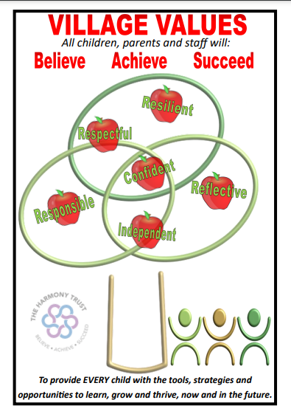
Village Values

To provide EVERY child with the tools, strategies and opportunities to learn, grow and thrive, now and in the future.

Respectful - So that children build positive relationships and understanding of each other.
Resilient - So that children can bounce back whatever happens.
Responsible - So that children know they are in charge of themselves and their choices.
Reflective - So that children can get better at what they do and learn.
Confident - So that children can succeed in a competitive world.
Independent - So that children are fully prepared for Key Stage 3.

Academy Rules

- To respect yourself
- To respect each other
- To respect the environment

The “Academy Rules” are closely linked to the British values of democracy, the rule of law, individual liberty and mutual respect for, and tolerance of, those with different faiths and beliefs and for those without faith.

If children follow these expectations, they can gain rewards. If pupils do not follow these expectations, there are consequences set out in this policy.

The aim of all consequences is two-fold
• To help pupils moderate their behaviour
• To ensure the orderly running of the school

The academy values and rules poster are displayed in all classrooms and other appropriate areas around academy. At the start of each academic year and throughout the year, class teachers will discuss the school expectations and refer to them frequently when praising positive behaviour choices as well as reminding the children when their choices are not in line with the high expectations that have been set.

Praise & Rewards
We use many different rewards in school. Here are just a few:
Verbal Praise
Staff tell children when they
have made good choices or
produced good work

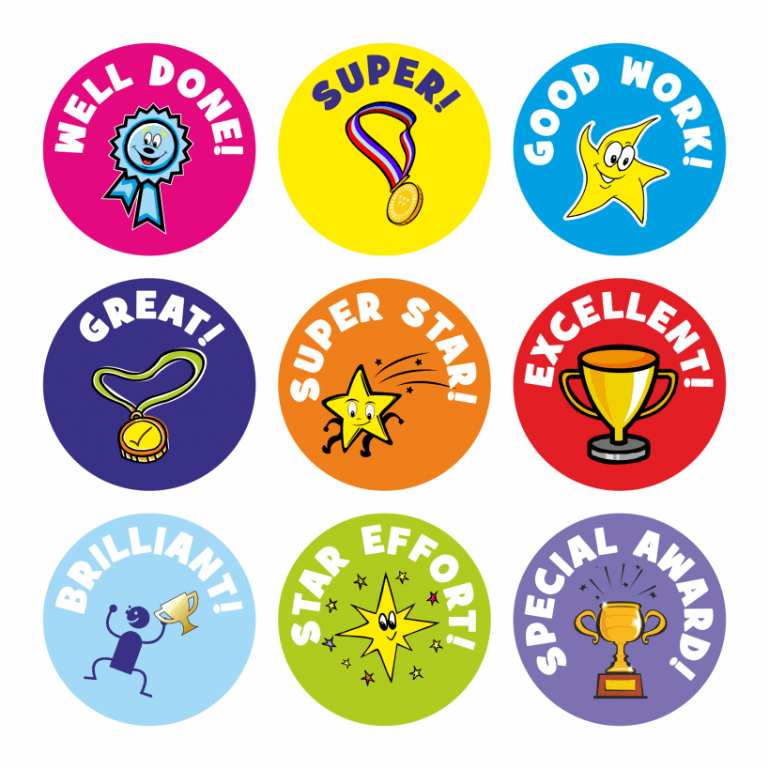
Stickers
Stickers will be given to
children for good work or
great choices

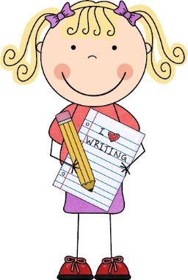
Sharing Work
Good work can be shared with
the SLT and put onto Class Dojo

Star of the Week
Children become ‘Star of the
Week’ for great effort in school

Class Dojos
Children receive Dojos that are linked to our Village Values.
Village Values
Respectful
Resilient
Responsible
Reflective
Confident
Independent
Dojo Tokens
Children could receive Dojo tokens
from any staff member in the school
Image needed
Dojo of the Week
The child with the most Dojo points
in a week receives a ‘Privilege Pass’

Learner Support
A number of support systems are in place to support the children and to promote good behaviour.
These include:
- Personal Behaviour Plans to target specific behaviours and have clear, set targets to work on
- The use of TAs on the playground at playtime and lunchtime to promote further stability
- Individual reward time earned
- Behaviour support and intervention groups such as soft landings, counselling sessions and
- 1:1 or small group social skills sessions
- External support from expert agencies if needed
- All school personnel work hard to ensure that these systems run smoothly and consistently.

Restorative practice
We want our children to understand that there are always consequences to our actions, therefore we have both positive and negative consequences, according to our behaviour choices.
If a child makes a negative choice about their behaviour they will have some reflection time where they will be supported to think about their actions, how this affected others, and how they can make better choices next time. Children will always be shown the academy vision and the Academy rules for expected behaviour, and this will allow them to make the right choice. If the behaviour of a child deteriorates, then a teacher will use the ladder system/pathway.

POSITIVE SIDES:
Other Reward systems in place
- Good work can be shown to the class, another class, another adult in school or copied to send home.
- A visit to the Executive Principal, Head of Academy, Deputy Principal or Assistant Principals for commendations.
- Children’s work can/should be displayed as much as possible both in the classroom and corridors of the school.
- Dojos, notes, positive card or texts can be sent home to inform parents of good work/behaviour. Dojos awarded are directly linked to the Village Values. Information about these Dojos are also shared with parents through class stories.
- Collective whole class rewards, for example ‘table points’ or stickers for a chart, marbles in a jar for positive behaviour, hard work or meeting class targets. Class teachers can tailor whole-class rewards to meet the needs of their class; they could also be aligned across the year group.
- Recognition can be given to success of differing kinds in assemblies, e.g. presentation of swimming and punctuality awards etc.
- Above all, praise and encouragement in and out of lessons should be used as much as possible.

Class dojo details
These are awarded on the interactive Class Dojo reward system; they are specific so the Village Values can be celebrated. Each child and their parent/carer will be given an individual login this will help to further develop lines of communication between home and school.
- Children will earn points throughout the day.
- One point will be awarded each time for positive learning behaviour linking to the Village Values.
- The child with the most points at the end of the week will be the “Dojo of the week” and be given a “Privilege Pass” reward to be worn as a lanyard (e.g. special chair in class, cushion to sit on, front of the line, first to break/lunch, special book to borrow). This to be awarded during the celebration assembly. This is in addition to “Star of the Week” in order to reward “always” children and those making a significant effort.
- Points will be reset on a weekly basis by the class teacher.
- Class Dojo “tokens” can be given out by non-class staff members to further promote positive behaviour.

Star of the week
This status awards children for effort, good behaviour and adhering to values. One child will be selected from each class each week and will be awarded a certificate during celebration assembly. This way, children with improving attitudes and behaviour can receive recognition.

“Team Time”
One hour per half term of timetabled, pre-planned, high-quality free choice activities that the children earn through their positive behaviour choices. This must be clearly communicated to all children at the start of each half term and regularly referred to, with input from the children about a preferred activity.
All children start the half-term being able to attend Team Time. However, any child who receives 3 or more “Step 4” sanctions within that half term, does not attend and will be supported during the session to set targets to achieve Team Time next half term, using the Behaviour Plan. Class teaching teams lead these half-termly sessions.

Class Champion for the term (Children’s Choice)
At the end of each term, each class chooses a Class Champion. This is normally voted on by the class (and any adults who work with the class). It should be based on the school’s ethos as to why the person is chosen. One child becomes their Sponsor. The Sponsor will stand up to explain why the class have voted for the Champion in the assembly. The class teacher does the same thing. The parents of the Champion are invited into the special assembly (pending Covid restrictions). There are gold covers for the chairs and the Sponsors sit in front of the champions.

Afternoon Tea with SLT
The child with the most class dojos per class will be selected to have afternoon tea half-termly with the phase leader.

Best Class Attendance
The class with the best attendance for the week within each phase (Rec, KS1, LKS2 and UKS2) will have the opportunity to win an attendance trophy and earn extra playtime for the week.

Communication with Parents/Carers

All parents/carers are encouraged to join Class Dojo as an effective and efficient means of communication. If for any reason, they are not signed up then parents/carers are contacted to do this via a letter home, a phone call or face to face conversation.

Class Dojo is the main form of communicating positive messages about a child with their parents/carers. As well as receiving updates on the number of dojos received, parents/carers can also view class and whole-school stories which include regular updates about what is happening.

School Stories are updated by SLT and Class Stories are updated by the class teacher on a regular basis.

Parents/carers are able to message teachers, securely, on their child’s individual portfolio. The
following rules must be followed:

- Messages should be used to find out about their child’s progress, behaviour, attainment and general class comments.
- Messages about attendance/illness are not permitted through Class Dojo; this must be communicated directly to the school office.
- Teachers may not reply immediately, especially if messaged out of working hours. If it is something that needs dealing with urgently then parents/carers must contact school (telephone or email to info@village.theharmonytrust.org) to arrange a meeting or speak to a member of staff at the next available opportunity.
- Parents/carers must be respectful towards staff, other parents/carers and children when commenting on class or school posts or messaging staff.

Consequence for poor behaviour
Dealing with disruptive and rule breaking behaviour is a graduated approach, from the least to the most intrusive. Even though it is acknowledged that warning and consequences are needed, they are to be used selectively. Teachers must actively build relationships with pupils and give praise, encouragement, incentives & celebrations. In particular, use of the 5:1 ratio for praise and warning/reminder of rules is necessary.
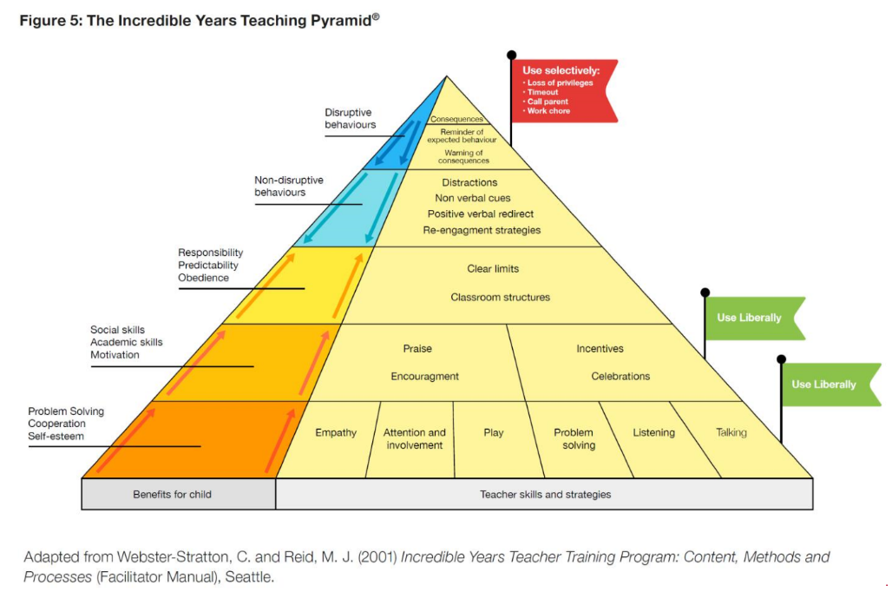
We work hard to ensure that discipline is consistent across the academy so that behaviour boundaries and sanctions are clear to all and are applied fairly, proportionately, and without discrimination, taking into account SEN needs and disabilities as well as the additional challenges that some vulnerable children may face. Staff are trained to deal with behavioural issues as part of their continual professional development.
Sanctions are applied consistently by all staff, but with the provision for flexibility to take account of individual circumstances. For children whom the whole-school behaviour approach is not appropriate at any time, due to recognised need, a separate behaviour plan for each individual will be in place.
We recognise that where individual children are engaging in continuing disruptive behaviour this can be as a result of mental health needs. If such needs are identified, we will do all we can to ensure that the child receives appropriate support. We recognise our legal duties under the Equality Act 2010 in respect of children with SEN and/or disabilities. Whilst all children identified with SEN and/or disabilities are covered under this behaviour policy, we recognise that these children often require support which is different from, or in addition to, that required by their peers in order to take full advantage of the educational opportunities available to all children.

An individual Behaviour Plan will be used for children whose SEN and/or disabilities cause them to display challenging behaviour. Advice will be sought from external agencies where necessary to assist with putting in place appropriate support strategies, which will be monitored and reviewed. Please read the Trust’s Special educational needs & Disability policy for more information.
We have an agreed system of sanctions to address unacceptable behaviour. When sanctions are applied, children should be helped to understand why what they have done is not acceptable.

Key steps and actions in tackling behaviour consequence steps

Every child starts their day on a positive note. If a Rule is broken, and verbal warnings ignored, their name is moved down the chart.
Step 1
Verbal Warning

Warning
Step 4
Very poor choices – sent to a senior
leader
Senior Leadership
Team
Step 3
If poor choices continue - time in
partner class
Step 2
Time out in class to think and
reflect
The steps in detail:
Step 1 - Redirection verbal warning given
Behaviour observed may include: not listening, messing about, not following instructions, wasting time or using hurtful comments. A gentle encouragement, a nudge in the right direction. A reminder of the Academy expectations and values.

Step 2 - Caution – Time out in reflection corner/zone/table in class for 10 minutes.
A clear verbal caution delivered privately wherever possible, making the learner aware of their behaviour and clearly outlining the consequences if they continue.

Step 3 - Use of partner class –
Continuation of low-level disruption (despite class reflection time) or more serious first-time offence.
Pupil sent to partner class and spend 5 minutes (KS1)/ 10 minutes (KS2) in the class reflecting on their behaviour.

Parents alerted via a call or meeting at the end of the day to inform them of the behaviour displayed. This is to inform parents of any behaviour concerns and build positive relationships to tackle concerning behaviours. Senior leaders will contact parents if the behaviour is a high concern or the behaviour is continually repeated. Teacher to record incident onto CPOMs on the same day.

Step 4 - Sent to SLT –
High-level first-time disruption. Behaviour observed may include: deliberately injuring somebody, bullying, stealing, destroying property, making repeated racist comments or already having been through Step 3.

If a child is sent to SLT, incidents for Step 4 are always recorded on CPOMs by class teacher. The class teacher must inform the parent/carer that the behaviour has occurred.
SLT will add any actions to the initial incident where appropriate.

Teachers may use other strategies that are reasonable and proportionate to any behaviour incidents. This may include but is not limited to
- Keeping pupils in at break/lunchtime to finish work
- Moving a pupil within the classroom
- Asking another adult in school to speak to the child
- Seclusion at lunchtime (with the agreement of SLT)

SLT may also use other strategies that are reasonable and proportionate to any behaviour incidents. This may include but is not limited to
- Seclusion at lunchtime/ break
- Internal seclusion (for 0.5 days or longer)

Break time/Lunchtime Behaviour
If a child has made the wrong choice at lunchtime, they are immediately asked to have time out with
an adult by sitting out or staying close to the adult to calm down and reflect.
If a more serious incident occurs for which the child needs to be removed from the playground then
a member of SLT can be called for.
SLT will then determine an appropriate consequence and feedback to one of the class adults who should then record this on CPOMs and inform the child’s parents/carers.
Pupils with persistent behaviour problems
Where pupils are persistently or seriously breaching the Academy rules, or if an incident occurs which staff deem to be highly unacceptable, a report must be completed on CPOMs and the SLT alerted.

These include incidents of:
- Verbal Abuse
- Threat of physical violence
- Actual physical violence
- Racial, Homophobic, Disability, Religion and belief, or Age Abuse
- Damage to belongings or property

All of the above will result in the child being placed at ‘Step 4’ on the consequence steps.

Exclusion or seclusion - Serious physical or verbal assault.
In line with the Trust policy, The Executive Principal reserves the right to use temporary and permanent exclusion. To be recorded as per Trust and Local Authority guidance.
Behaviour Plan
If a child has made multiple wrong choices (step 4) in a half-term, a member of SLT will meet with the parent/s of the child and decide on an appropriate course of action. This may include implementing a behaviour plan. SLT reserve the right to use all reasonable and appropriate consequences in order to stop poor behaviour this includes, but is not limited to, break time seclusions, lunchtime seclusions or break time/lunchtime plans.

A behaviour plan will identify the warning signs, triggers and will have targets for the child to achieve. This is a plan that will involve all adults who work with the child, SLT, parents and the child themselves. The purpose of the plan is to change the child’s behaviour. Each plan will identify key adults who can help that child – especially when they are experiencing a behavioural crisis. Whenever there is a serious incident for a child on a plan, the incident will be reviewed to ensure the plan has been followed.

