Village Primary Academy

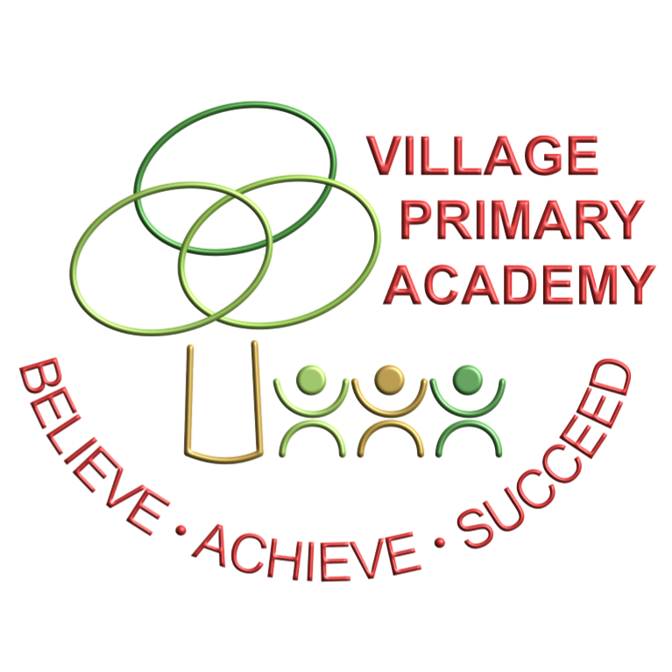

Remote Education Provision – Information for Parents

Remote education provision: information for parents
This information is intended to provide clarity and transparency to pupils, parents and carers about what to expect from remote education where national or local restrictions require entire cohorts (or bubbles) to remain at home.
For details of what to expect where individual pupils are self-isolating, please see the final section of this page.

The remote curriculum: what is taught to pupils at home
.
Each class will meet together ‘live’ each week for a class story time or discussion activity, which we feel is essential contact with a class teacher and peers and helps the children to maintain a sense of connectedness with their class teacher, TA and their class friends. The length of the live sessions will vary according to the age of the children.

What should my child expect from immediate remote education in the first day or two of pupils being sent home?
- Ensure appropriate links to online platforms are shared with all parents/carers.
- Identify any children who do not have access to any ICT at home to enable effective home learning.
- Consider the loan of IT equipment to children identified above – issue loan agreements to parents and carers.
- Prepare hard-copy packs of home learning for any children who cannot access IT equipment and are unable to borrow equipment from school.
- Make arrangements for class teachers and teaching assistants to regularly contact children by telephone.
- Staff to prepare lessons and deliver through the period of lockdown, ensuring that the work is differentiated where appropriate.

Following the first few days of remote education, will my child be taught broadly the same curriculum as they would if they were in school?
We teach the same curriculum remotely as we do in school. However, we may need to make some adaptations in some lessons – for example in PE where we are using specific equipment to teach a skill, we are aware that these resources may not be available at home and so the lesson may be modified. We also understand that many of you will be trying to work whilst your child may be at home and as such may modify activities to ensure that the children do not always require significant adult intervention.

Remote teaching and study time each day

How long can I expect work set by the school to take my child each day?
We expect that remote education (including remote teaching and independent work) will take pupils broadly the following number of hours each day:
EYFS | Approximately 2 hours 30 minutes, this includes both adult directed and free choice play activities.
Key Stage 1 | 3 hours per day.
Key Stage 2 | 4 hours per day.

Accessing remote education

How will my child access any online remote education you are providing?
We use the Purple Mash platform and the 2Dos within this to support the teaching and learning at home. We will provide a weekly timetable for each class with suggested times for each lesson. We will also send home a daily email with attachments and further learning which cannot be provided through Purple Mash. We may provide some recorded lessons to help to support the children’s learning and this will also enable you to manage your time whilst both working from home and helping the children with their lessons.

If my child does not have digital or online access at home, how will you support them to access remote education?
We recognise that some pupils may not have suitable online access at home. We take the following approaches to support those pupils to access remote education:
- Identify any children who do not have access to any ICT at home to enable effective home learning.
- Consider the loan of IT equipment to children identified above – issue loan agreements to parents and carers.
- Prepare hard-copy packs of home learning for any children who cannot access IT equipment and are unable to borrow equipment from school.
- Make arrangements for class teachers and teaching assistants to regularly contact children by telephone.
- Work can be submitted to the class teacher via the school email address and Dojo if access to 2-Email on Purple Mash is not possible.

How will my child be taught remotely?
We use a combination of the following approaches to teach pupils remotely:
The high-quality curriculum we have designed is a mixture of specific teacher input and software to set a learning pathway planned to provide educational progress for all children. Well-being, creativity and physical education are equally important within our remote learning curriculum design.
Teachers will feedback to individuals via Purple Mash, 2Email or Dojo and the remote learning offer will be aligned with the curriculum which would normally be taught in school.
For teacher input, teachers will select the most appropriate method to explain new concepts. This may include videos or pre-recorded slides with a voice over.
The Academy will use a range of resources and methods to deliver remote learning and help explain concepts easily. For the purpose of providing remote learning, the Academy will use a combination of:
- Purple Mash 2-Dos
- Tasks sent via 2Email.
- Recorded teaching (e.g., Oak National Academy lessons, BBC bitesize)
- Printed work packs produced by teachers.
- Educational websites – (e.g., MyOn, Phonics Play)

Engagement and feedback

What are your expectations for my child’s engagement and the support that we as parents and carers should provide at home?
During the period of remote learning, the school will maintain regular contact with parents/carers to:
- Reinforce the importance of children staying safe online.
- Ensure parents are aware of what their children are being asked to do.
- Encourage them to set age-appropriate controls on devices and internet filters to block malicious websites.
- Ensure children are completing their learning.

How will you check whether my child is engaging with their work and how will I be informed if there are concerns?
Teaching staff will oversee academic progress for the duration of the remote learning period and will mark and provide feedback on work.
- Work will be monitored during the school day.
- Staff will respond to every 2-Do to encourage or reset as appropriate.
- Staff will respond to emails with questions once a day during their working hours.
- Staff will monitor engagement. If your child has not engaged, a member of staff will contact you to check you can access work.

All schoolwork completed through remote learning must be:
- Finished when returned to the relevant member of staff.
- Returned on or before the deadline set by the relevant member of staff (we understand you are organising learning and working from home – just let us know if you are finding the deadlines difficult to meet.
- Completed to the best of the child’s ability
- The child’s own work.

How will you assess my child’s work and progress?
Feedback can take many forms and may not always mean extensive written comments for individual children. For example, whole-class feedback or quizzes marked automatically via digital platforms are also valid and effective methods, amongst many others. Our approach to feeding back on pupil work is as follows:
- Children are accountable for the completion of their work – school staff will contact parents if the child is not completing the learning or their standard of their work has noticeably decreased.
- Teaching staff will monitor the progress of pupils with and without access to the online learning resources and discuss additional support or provision with the Year Group Leader.
- Teaching staff will monitor the academic progress of children with SEND and discuss additional support or provision with the SENDCo as soon as possible.

Additional support for pupils with particular needs

How will you work with me to help my child who needs additional support from adults at home to access remote education?
We recognise that some pupils, for example some pupils with special educational needs and disabilities (SEND), may not be able to access remote education without support from adults at home. We acknowledge the difficulties this may place on families, and we will work with parents and carers to support those pupils in the following ways:
- Access to differentiated Purple Mash email and 2Dos.
- 1-1 learning sent home via Purple Mash where appropriate.
- IEPS shared with parents with advice how they can work on targets within these.
- Identified SEND children provided with IEP target resource pack.
- EHCP Risk Assessment updated to ensure the EHCP provision is being met.
- Face to face Teams lessons for specific individuals (1x weekly)
- EAL vocabulary resources are provided where appropriate.
- Symbolised resources are provided where necessary.
- Materials/resources/guidance from external agencies e.g., SALT, Educational Psychologist etc are sent home and shared with individual parents.
- The SENDCo will arrange additional support for children which will be unique to the individual’s’

Remote education for self-isolating pupils
Where individual pupils need to self-isolate but the majority of their peer group remains in school, how remote education is provided will likely differ from the approach for whole groups. This is due to the challenges of teaching pupils both at home and in school.

If my child is not in school because they are self-isolating, how will their remote education differ from the approaches described above?
There will be no difference in the provision of learning for individuals who are self-isolating but are not unwell.
Children will receive feedback on their work submitted through Purple Mash or by email by the end of the working day. Any questions from parents or requests for support may not be addressed until the end of day as staff are in school and focussing on teaching all day.

